Howard House Children’s Home and School



Child Friendly Anti-Bullying Policy

**If you are bullied:-**

**DO:-**

* Ask them to STOP if you can.
* Use eye contact and tell them to go away.
* Ignore them.
* Walk away.
* TELL SOMEONE.

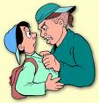

**DON’T:-**

* Do what they say.
* Get angry or look upset.
* Hit them.
* Think it’s your fault.
* Hide it.
* Don’t retaliate.

**What should I do if I see someone else is being bullied?**

* Don’t walk away and ignore the bullying
* Let the bully know what is happening
* Tell the bully to stop if it is safe to do so.
* Don’t stay silent or the bullying will keep happening
* Don’t lose your temper

**The Head Teacher, the staff, and the children here will work together to:-**

* Make Howard House school a place where everyone can feel safe and happy. That means no bullying allowed.
* We will help everyone to get on with each other and we believe that everyone has the right to be who they are.

**Who can I tell?**

A Friend

A member of Staff

The School Teachers

The Head Teacher

Your Social Worker

Any Other Adult



MOST IMPORTANTLY:-

If you are being bullied:

**Start Telling Other People!**

**When is it bullying?**

Several

Times

On

Purpose

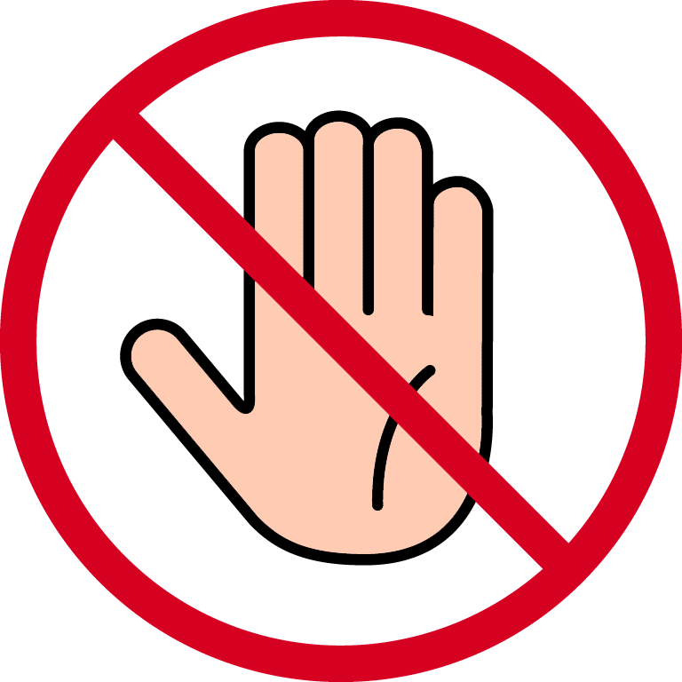

**At Howard House we promise to always treat bullying seriously.**

**What is Bullying?**

A bully is someone who hurts someone more than once, by using behaviour which is meant to hurt, frighten or upset another person.

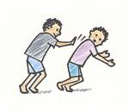

**Bullying Can be……**

**Emotional:** Hurting people’s feelings, leaving you out.

**Physical:** Punching, kicking, spitting hitting, pushing.

**Verbal:** Being teased, name calling.

**Racist:** Graffiti, calling you racist names.

**Cyber:** saying unkind things by text, e-mail and msn messenger.